Multispecies consequences of fishing in the North Sea

This application is a Cefas contribution to the Pandora toolbox which uses the novel ensemble methods of Spence et al. (2018) to combine four mechanistic multispecies fish community models to produce, with quantifiable uncertainty, predictions of equilibrium response of 9 key commercial North Sea species to different rates of fishing, in terms of SSB and risk of depletion.

Setting up the app

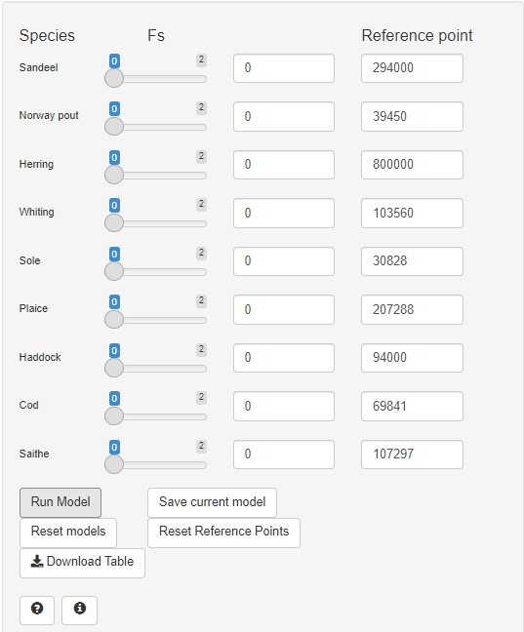
1
- Fs slider
- Fs text input
- Reference point
- Run scenario
- Save current scenario
- Remove scenarios
- Reset reference points
- Download results
8
7
6
5
4
3
2

Prior to running a scenario, input parameters for each species can be changed using the sliders and numeric input boxes on the left hand side of the app. Each species has two inputs;
- Fs, the fishing mortality of that species, which can be changed using the slider (1) or typed into the numeric input box (2). Fs inputs are restricted between 0 and 2.
- Reference point (Blim), which can be typed into the numeric input box (3). Pressing the Reset Reference Points button (7) will change all reference points back to their initial value, B_{lim} from the ICES advice.

Running the scenario

After deciding on the future fishing mortality values, press the Run Model button (4). The app will populate the right hand side of the display with plots of the equilibrium SSB and a table.

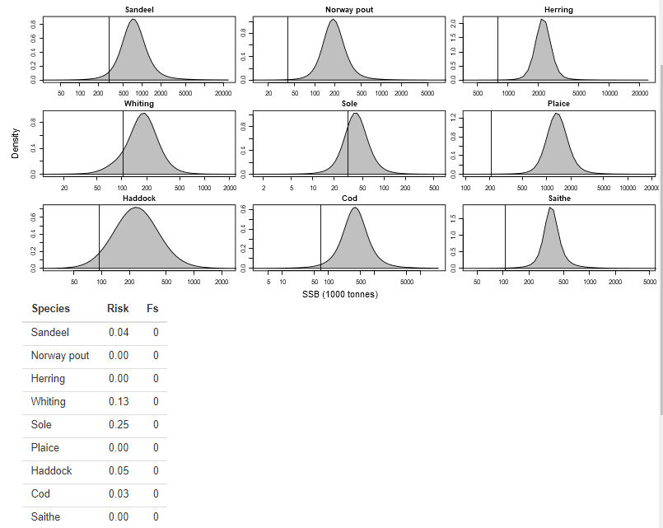
- Graphical outputs
- Reference point marker
- Output table
11
10
9

Nine plots will be generated, showing the result for each of the nine species (9). The vertical line on each plot (10) will show the chosen Reference Point position. The table (11) will show both your risk (which is the probability that the long-term SSB will be below the reference point Reference Point input, see the app information for more details) and the input fishing mortality (Fs) for each species.

Note that updating the Reference Point in the input bar (3) will update the graphs (10) and table (11) without having to rerun the scenario.

Comparing Scenarios

After running a scenario you can store it in the app to compare it to another set of inputs. Pressing Save Current Model (5) will store the last scenario you have run (the scenario currently displayed in the graphs and tables).

Once you have stored a scenario, pressing Run Model (4) will run a new scenario, displaying the new results in red over the existing plot.

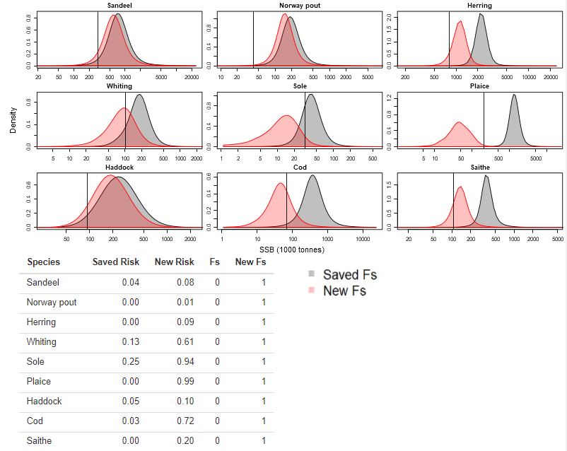

The table also updates, including the Fishing mortality (Fs) and risk for both the saved scenario and the new scenario. Changing the inputs and pressing Run Model (4) will only compare to the scenario you saved. Pressing Save Current Model (5) again will change your saved scenario to the fishing mortalities you last ran. Pressing Reset Models (6) will remove all current scenarios and outputs from the app, allowing you to run a fresh scenario.

Saving outputs

You can download the output table by pressing Download Table (8). This will save a copy of the table (11) along with the current date and time.

